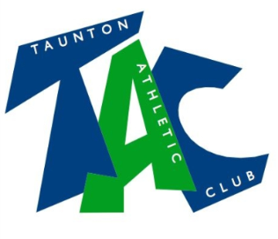
U15 Track & Field Club Records
 | U15 Boys | U15 Girls
Track Events
100 metres | Ronnie Wells 11.2 (2010) | Seren Rodgers 12.63 (2019)
200 metres | Ronnie Wells 23.0 (2010) | Freya Norton 26.5 (2006)  Phoebe Bryant 26.5 (2010)
300 metres | Elliot Scott 37.14 (2012) | Lucy Ann Stennett 42.1 (2016)
400 metres | Elliot Scott 51.21 (2012)
800 metres | James Merryfield 2:01.8 (1975) | Holly Brown 2:20.81 (2011)
1500 metres | Oscar Lee 4:19.25 (2017) | Isla Ness 4:49.04 (2007)
3000 metres | Blair Brown 9:41.7 (2008) | Holly Brown 10:46.15 (2011)
Mile | Dan Wilde 4:52.37 (2013) | Alex Sheehan 6:15.3 (2009)
1500 S/C (Fem height)
80m/75m Hurdles | Oliver D’Rozario 11.11 (2018) | Lydia Smith 11.17 (2018)
Field Events
Long Jump | Oliver D’Rozario 6.31 (2018) | Lydia Smith 5.87 (2018)
High Jump | Luke Webber 1.83 (2006) | Maya Jones 1.63 (2017)
Triple Jump | Oliver D’Rozario 12.87 (2018) | Ellie Carrow 10.35 (2016)
Pole Vault | Sam Leitch 3.10 (2009) | Seren Rodgers 2.20 (2019)
Javelin | Robin Danaher 54.67 (2008) | Josie Loxton 38.41 (2011)
Shot Putt | Hayden Tyler 13.39 (2008) | Izzy Jeffs 11.84 (2006)
Discus | Ben Crosby 36.23 (2019) | Katie Cross 34.75 (2011)
Hammer | Lee Nightingill 41.96 (2012) | Sarah Cavill 31.36 (2014)
Combined Events
Pentathlon | Oliver D’Rozario 3051 pts (2018) | Seren Rodgers 3096 pts (2019)
Relay
4 x 100 metres | 47.84 (2018) SWAL May | 52.0 (2005)  Norton, Morley, Wessley, Dyer
4 x 300 metres | 2:44.11 (2018) – SWAL July 2018 | 2:57.60 (2016) SWAL 3
4 x 400 metres | 3:57.7 (2011)  Scott, Macconnell,Reynolds,Walton

